Exploratory Data
This exercise explores a dataset containing layoff information from companies around the world. The analysis mainly compares layoffs across different industries and locations, focusing on the percentage of employees laid off and the total number of layoffs.
The first few rows of the dataset:
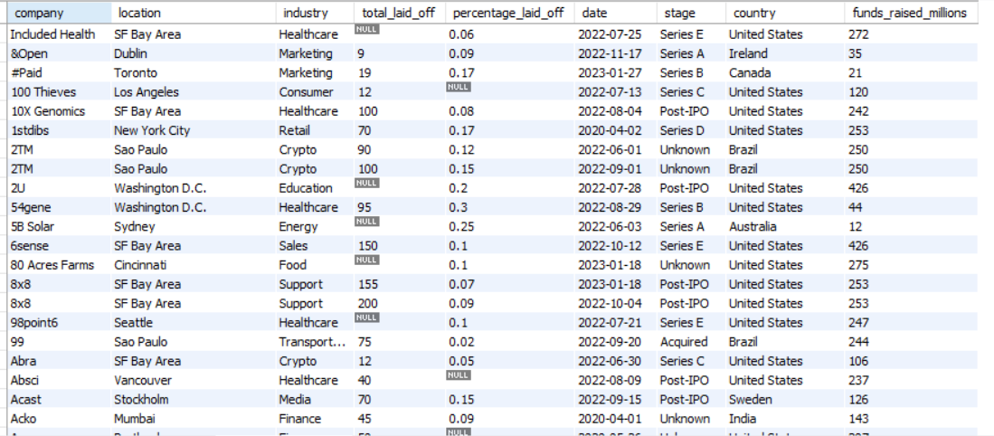
1. Determine the timeframe of the dataset

Recognizing that the timeframe occurs during the middle of COVID-19 pandemic, this is an important factor that greatly affected the data and influenced layoff trends across industries and locations.
2. Determine the maximum laid off numbers and maximum percentage
 1 is 100%
The company has the biggest laid off number in a day is:
There is total of 116 companies who has percentage laid off is 1, which means they laid off every employee they have.
This is some of the companies who has percentage laid off is 1 (100%) and sorted by descending raised funds in millions. The lead in the group is company Britishvolt from London, United Kingdoms, with the total laid off of 206 in a day and 2400 millions of funds.
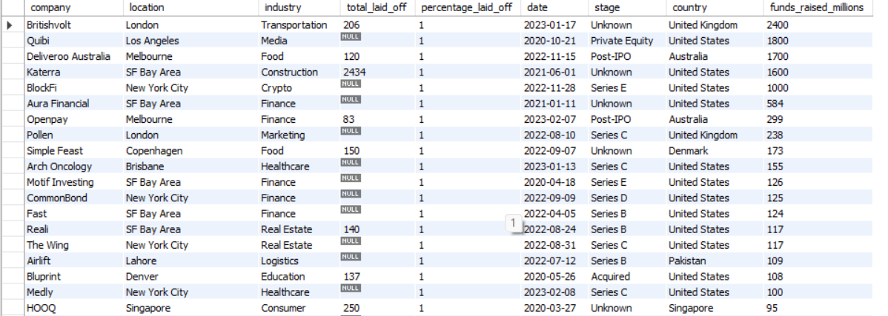
3. Determine companies that has the most laid off number throughout the timeframe
Among the companies with the highest number of layoffs, the United States accounted for the largest share, led by Amazon. We will examine and verify this hypothesis through the next step of analysis.

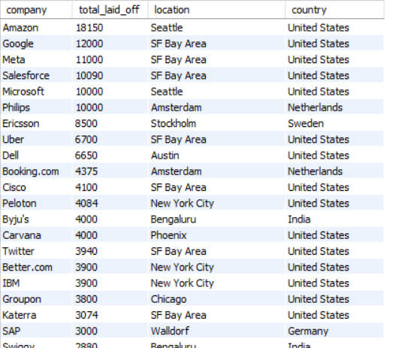

4. Determine the country has the most laid off
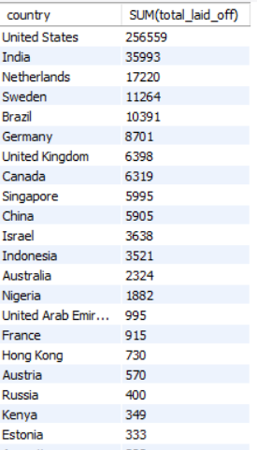
The United States leads the table with the sum of around 256559 laid off employees, which is roughly 8 higher than India in second place. This suggests the US workforce was most heavily impacted, reflecting how strict distancing measures (like the 2-meter social distancing rule) and lockdown disruptions reduced business activity and forced large-scale layoffs.

5. Determine the top 10 industries most affected by this timeframe
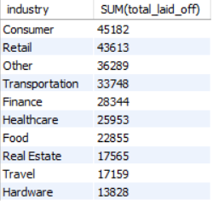
The data shows that the Consumer industry had the highest number of layoffs, followed closely by Retail and Other sectors. This suggest that the consumer-driven industries were most heavily affected during the COVID-19 period due to reduced demand and economic uncertainty.

6. Determine total number of layoffs by time

The dataset shows that layoffs varied significantly by year, with 2023 already reaching about 125,000 layoffs in just the first 3 months, indicating a very sharp spike in a short period. This suggests that the pace of layoffs accelerated compared to previous years, even without a full year of data.

With the rolling data sorted by month, the trend is explained by the fact that in just the first month of 2023 alone, layoffs reached nearly 85,000, which heavily contributes to the sharp increase observed in the early part of the year.

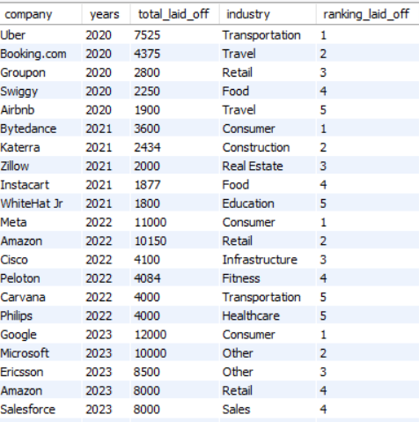
7. This table summarizes the top companies with the highest layoffs each year (ranked 1–5) from 2020 to 2023.
Overall, it shows a clear shift from travel and consumer-focused companies in 2020 such as Uber, Booking.com, and Airbnb, toward large tech and enterprise companies in later years like Meta, Amazon, Google, and Microsoft.
A key pattern is that layoffs became more concentrated in big tech over time, especially in 2022 and 2023, suggesting broader industry restructuring beyond just the early pandemic effects.

